Guys nothing personal going further, lets hold on to our horses on posting our quire / ques and post it only when Mr. Aravind mention if we have any quire / ques.

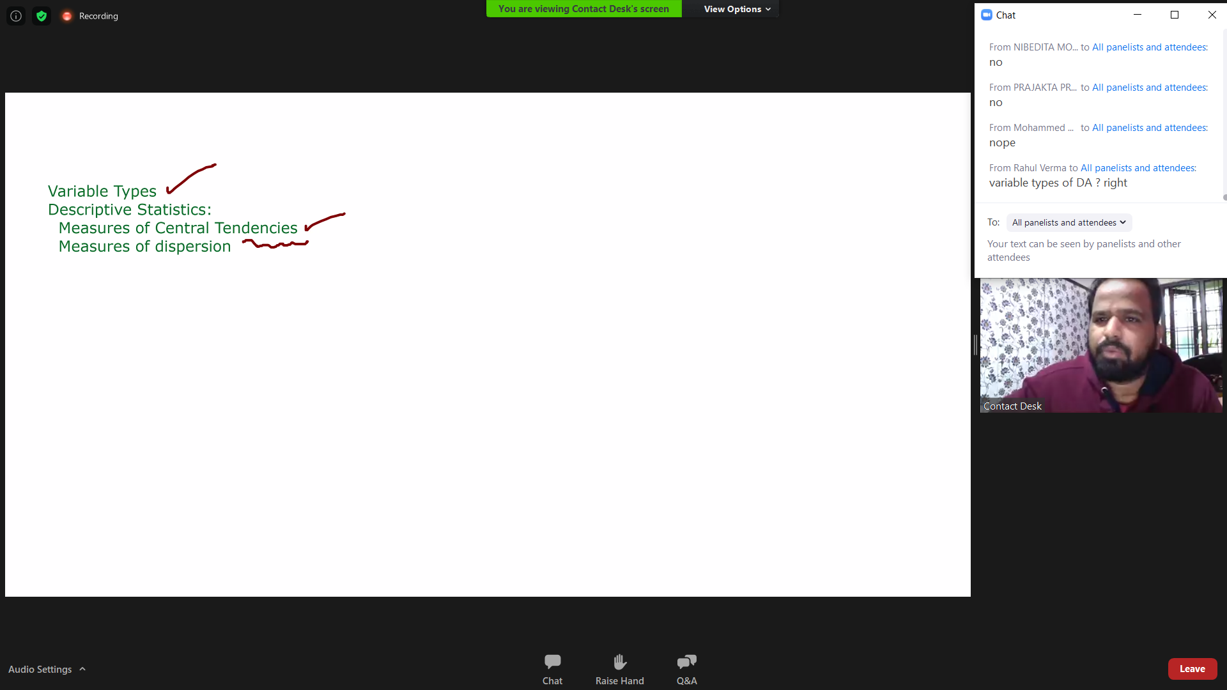

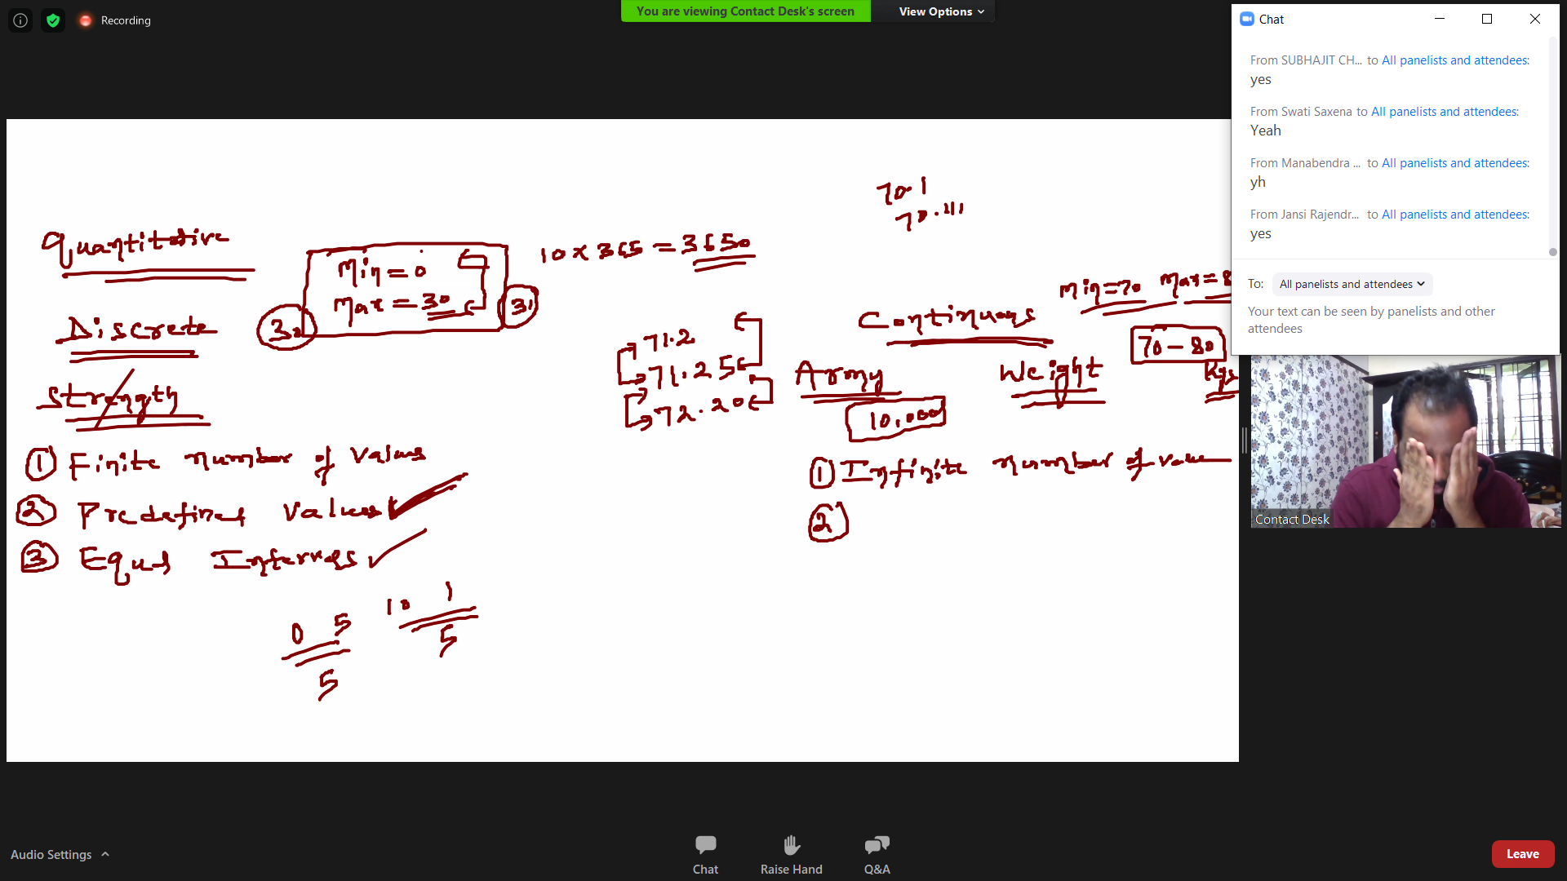

Discrete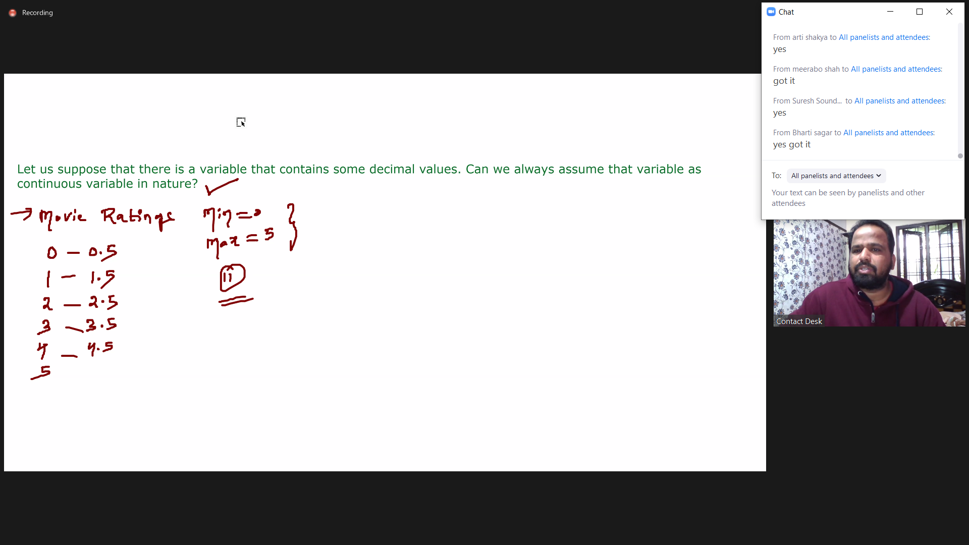

continuous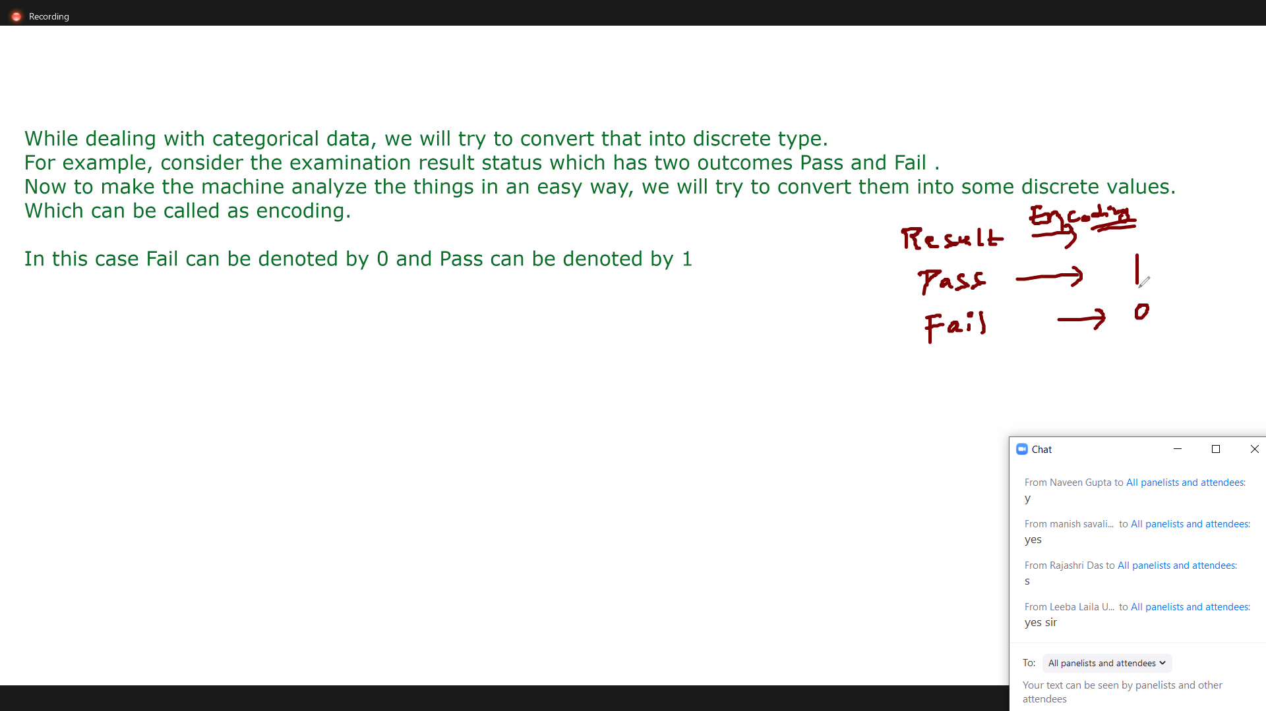

Dependent Variable is the one which gives response/target/prediction

In Sales-Discount example..... As per my understanding......Apparently Discount is always act as response and sales as predictor.....because if Sales is going good.. no one will think of discounts.... hence Discount is directly proportional to Sales....More discounts---> if less Sales and Zero/less discount---> if good Sales.....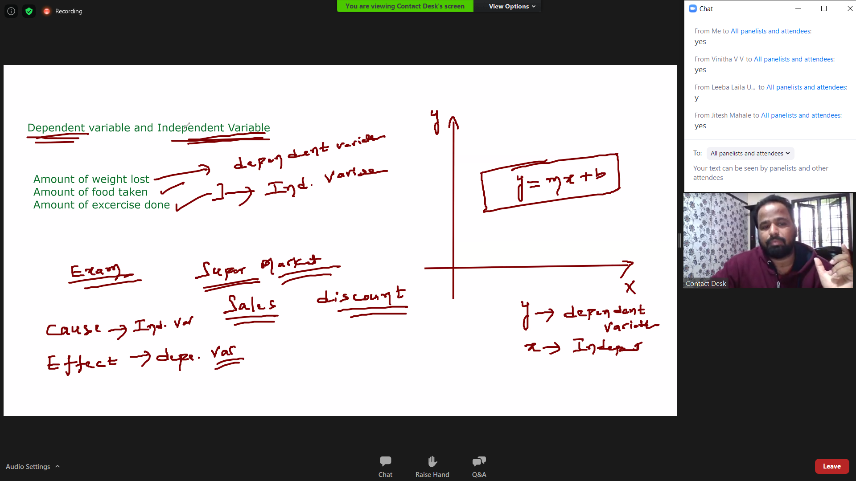

Univariate--> Bivariate -> Multivariate

Univariate -> understanding line by line (looking into 1 line)

Bivariate -> understanding if data is linked / see data is dependent to if Univariate

Multivariate -> understanding if data is linked / see if data is dependent to Bivariate

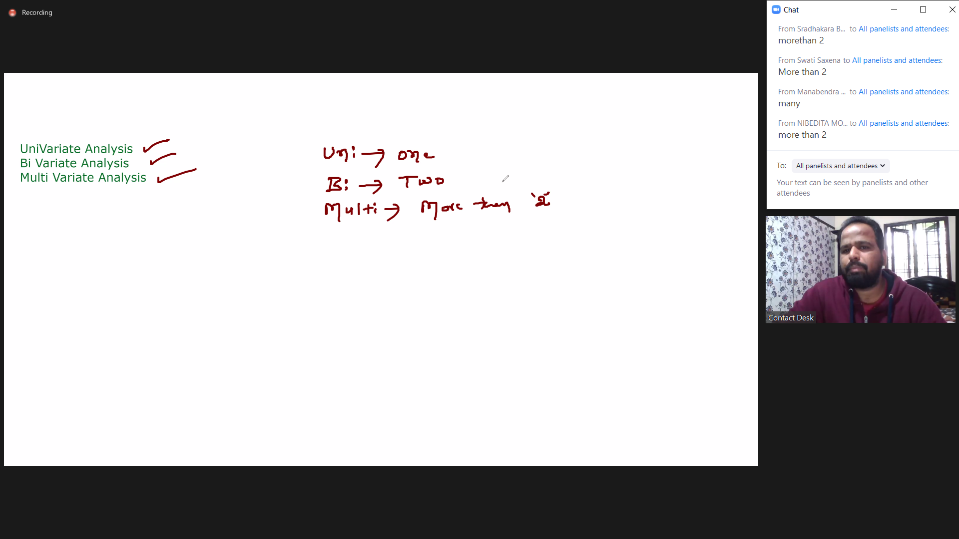

Analysis means to find out the Predictors and response so that we can find out the relations and to do so we need to start with univariate and then proceed to bivariate and further to multivariate....so that we can cover the whole data

-------------------------

Parameter is for Population (P for p)

Statistic is for Sample (S for s)

Parameter & Statistic = Statistics is input for Parameter

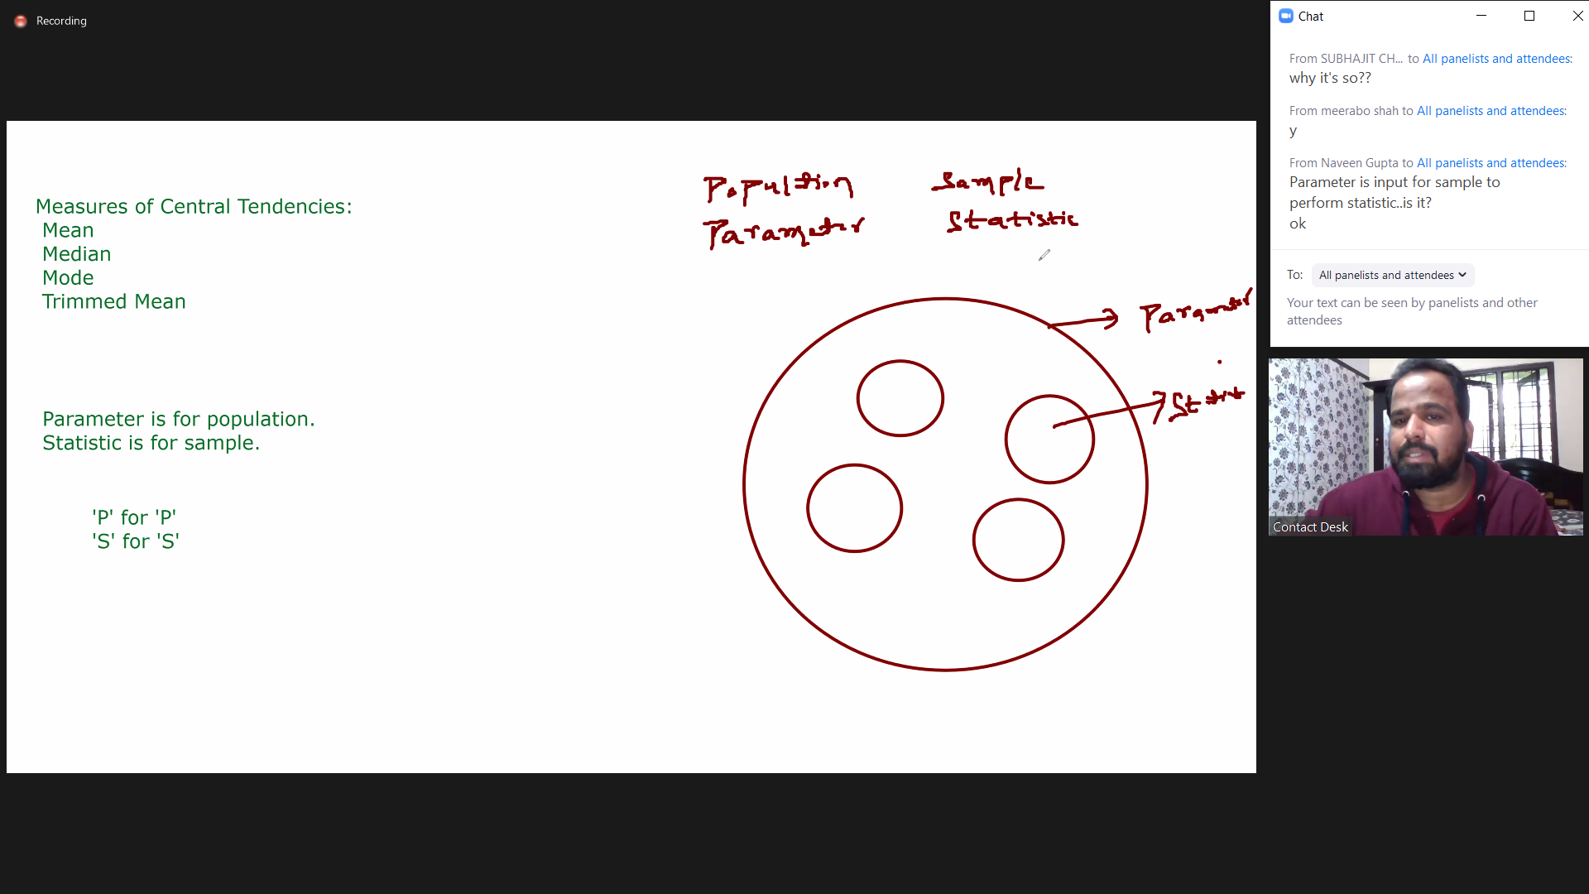

Measures of central tendency

Measures of dispersion

**Measures of central tendency**

The mean is the usual average

mean meant for Population and average meant for Sample.

=SUM of total / number of lines

The median is the middle value

The mode is the number that is repeated more often than any other

= In 1 2 3 4 5 6 **no mode** because no repeated

= In 1 2 3 4 5 6 2 6 Here 2 and 6 is **mode**

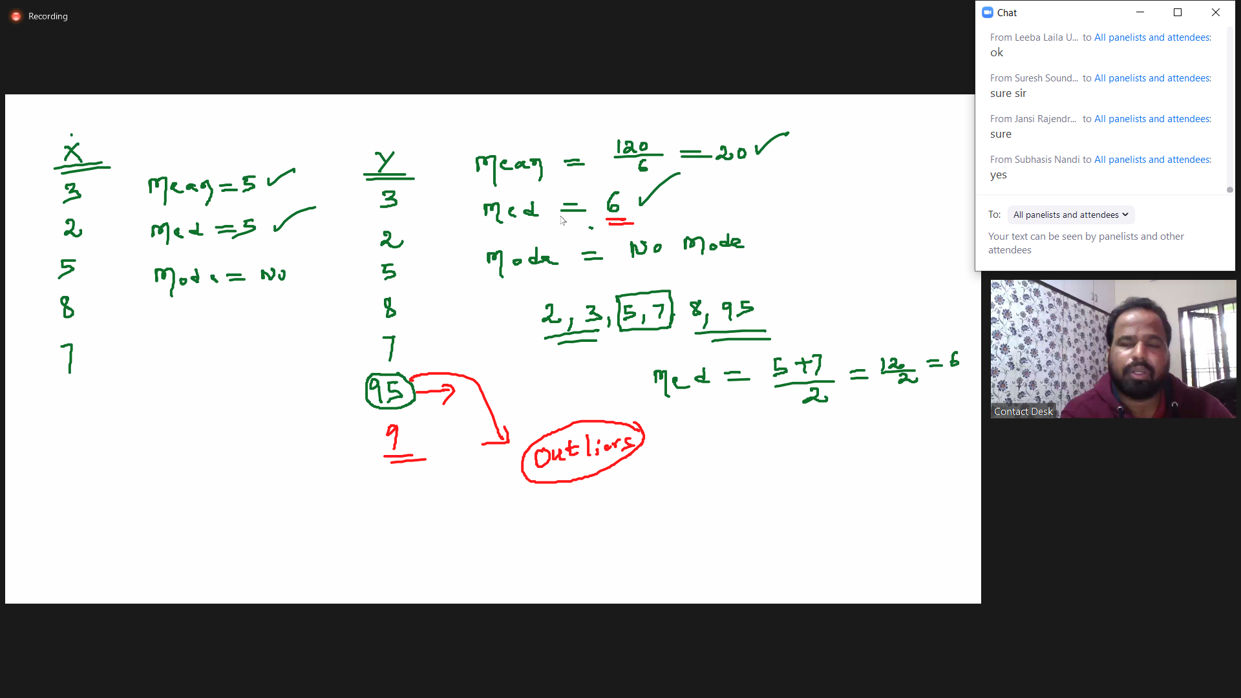

**Day 4**

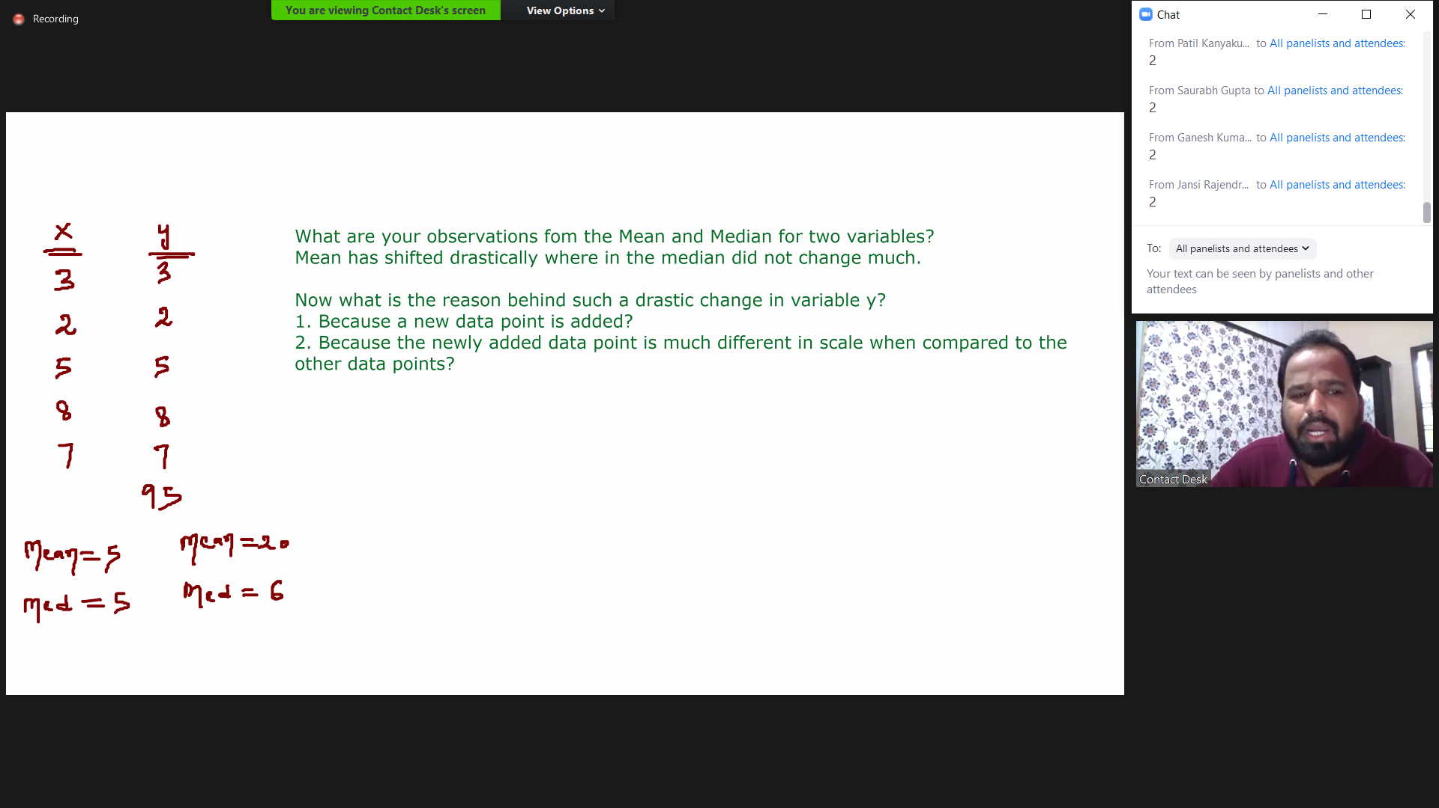

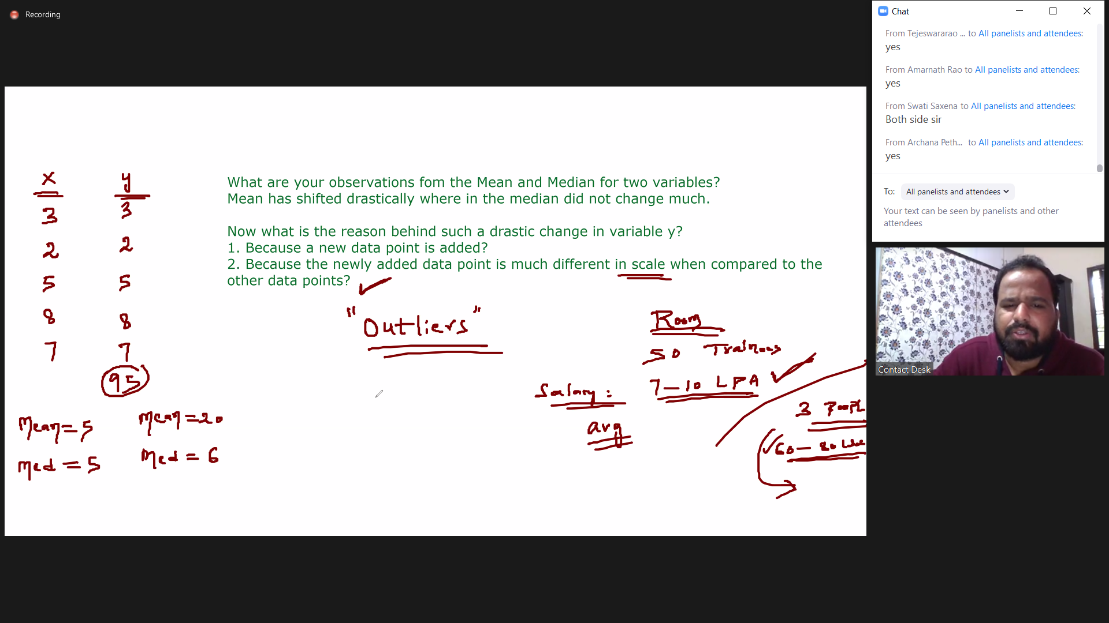

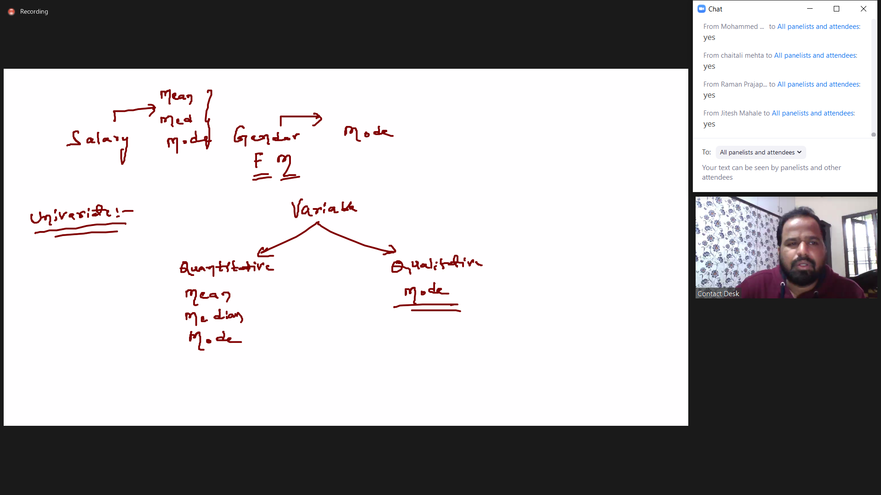

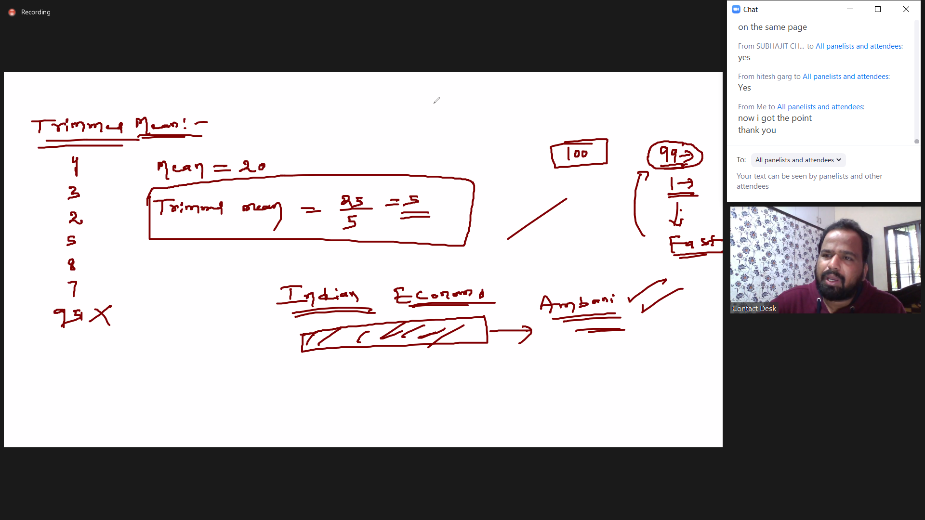

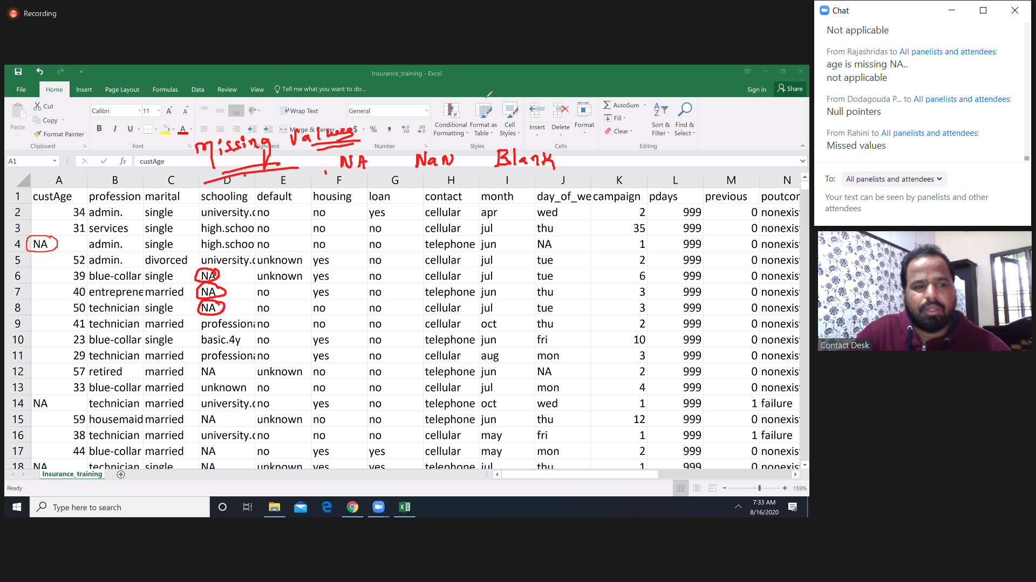

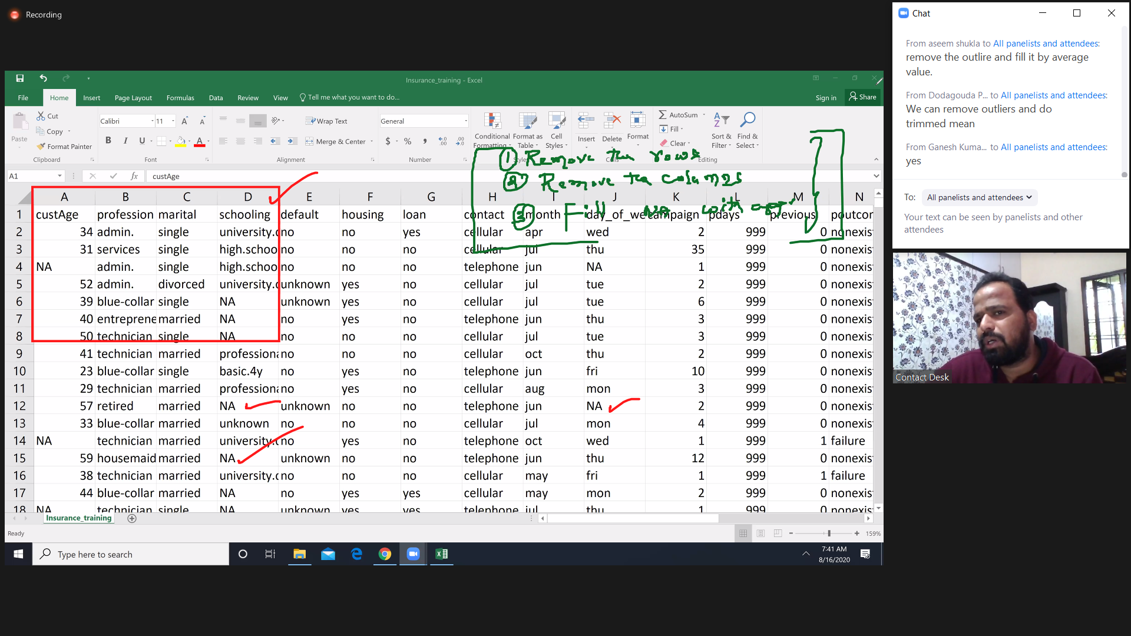

EDA

